European Exploration
Name: ___________________________ Date: _________ Block: _____

Prince Henry The Navigator (1394-1460)
Country Explored For: __________________
Dates of Exploration: __________________
Goals: ______________________________
Discoveries & Achievements: ____________
____________________________________
____________________________________
____________________________________
____________________________________

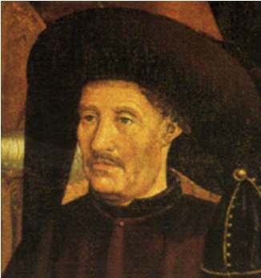

Notes: _______________
_______________________________________________________________
_____________________

Bartholomeu Dias (1451-1500)
Country Explored For: __________________
Dates of Exploration: __________________
Goals: ______________________________
Discoveries & Achievements: ____________
____________________________________
____________________________________
____________________________________
____________________________________

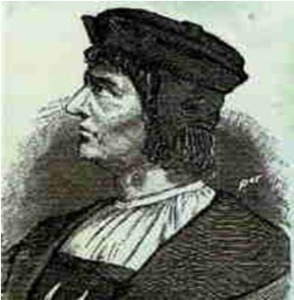

Notes: _______________
_______________________________________________________________
_____________________

Christopher Columbus (1451-1506)
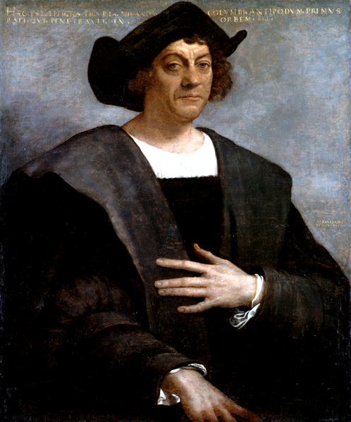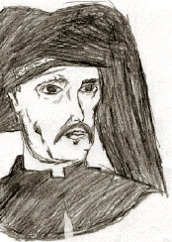
Country Explored For: __________________
Dates of Exploration: __________________
Goals: ______________________________
Discoveries & Achievements: ____________
____________________________________
____________________________________
____________________________________
____________________________________

Notes: _______________
_______________________________________________________________
_____________________

John Cabot (1450-1499)
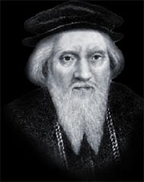
Country Explored For: __________________
Dates of Exploration: __________________
Goals: ______________________________
Discoveries & Achievements: ____________
____________________________________
____________________________________
____________________________________
____________________________________

Notes: _______________
_______________________________________________________________
_____________________

Vasco de Gama (1469-1524)
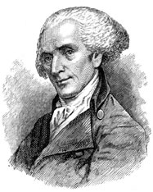
Country Explored For: __________________
Dates of Exploration: __________________
Goals: ______________________________
Discoveries & Achievements: ____________
____________________________________
____________________________________
____________________________________
____________________________________

Notes: _______________
_______________________________________________________________
_____________________

Pedro Álvares Cabral (1467-1520)
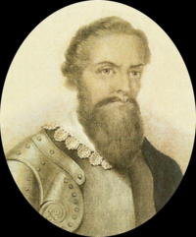
Country Explored For: __________________
Dates of Exploration: __________________
Goals: ______________________________
Discoveries & Achievements: ____________
____________________________________
____________________________________
____________________________________
____________________________________

Notes: _______________
_______________________________________________________________
_____________________

Amerigo Vespucci (1454-1512)
Country Explored For: __________________
Dates of Exploration: __________________
Goals: ______________________________
Discoveries & Achievements: ____________
____________________________________
____________________________________
____________________________________
____________________________________

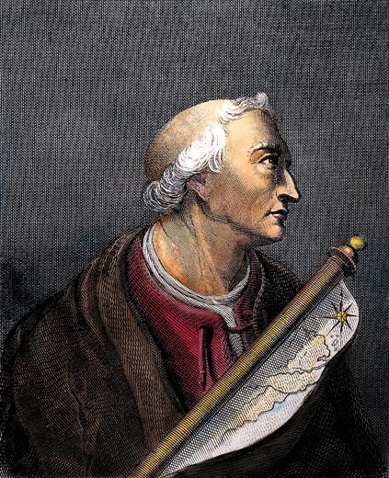

Notes: _______________
_______________________________________________________________
_____________________

Vasco Núñez de Balboa (1457-1519)
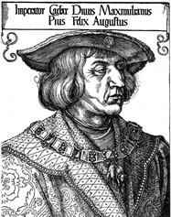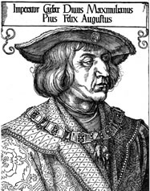
Country Explored For: __________________
Dates of Exploration: __________________
Goals: ______________________________
Discoveries & Achievements: ____________
____________________________________
____________________________________
____________________________________
____________________________________

Notes: _______________
_______________________________________________________________
_____________________

Ferdinand Magellan (1480-1521)
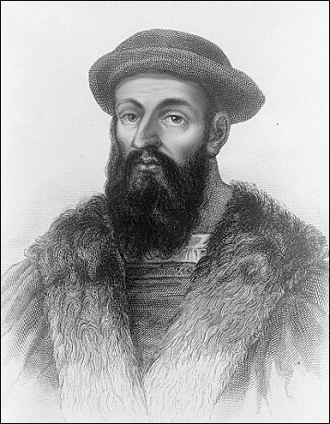
Country Explored For: __________________
Dates of Exploration: __________________
Goals: ______________________________
Discoveries & Achievements: ____________
____________________________________
____________________________________
____________________________________
____________________________________

Notes: _______________
_______________________________________________________________
_____________________

Juan Ponce de León (1474-1521)
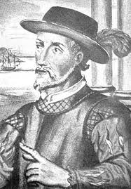
Country Explored For: __________________
Dates of Exploration: __________________
Goals: ______________________________
Discoveries & Achievements: ____________
____________________________________
____________________________________
____________________________________
____________________________________

Notes: _______________
_______________________________________________________________
_____________________

Álvar Núñez Cabeza de Vaca (1488-1558)
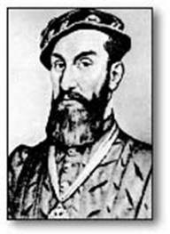
Country Explored For: __________________
Dates of Exploration: __________________
Goals: ______________________________
Discoveries & Achievements: ____________
____________________________________
____________________________________
____________________________________
____________________________________

Notes: _______________
_______________________________________________________________
_____________________

Hernando de Soto (1496-1542)
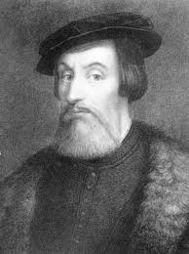
Country Explored For: __________________
Dates of Exploration: __________________
Goals: ______________________________
Discoveries & Achievements: ____________
____________________________________
____________________________________
____________________________________
____________________________________

Notes: _______________
_______________________________________________________________
_____________________

Francisco Vásquez de Coronado (1510-1554)
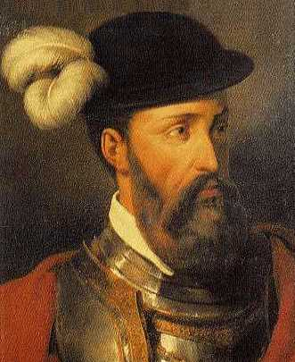
Country Explored For: __________________
Dates of Exploration: __________________
Goals: ______________________________
Discoveries & Achievements: ____________
____________________________________
____________________________________
____________________________________
____________________________________

Notes: _______________
_______________________________________________________________
_____________________

Jacques Cartier (1491-1557)
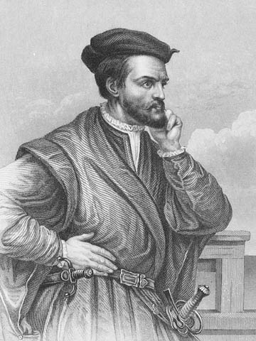
Country Explored For: __________________
Dates of Exploration: __________________
Goals: ______________________________
Discoveries & Achievements: ____________
____________________________________
____________________________________
____________________________________
____________________________________

Notes: _______________
_______________________________________________________________
_____________________

Henry Hudson (1560-1611)
Country Explored For: __________________
Dates of Exploration: __________________
Goals: ______________________________
Discoveries & Achievements: ____________
____________________________________
____________________________________
____________________________________
____________________________________

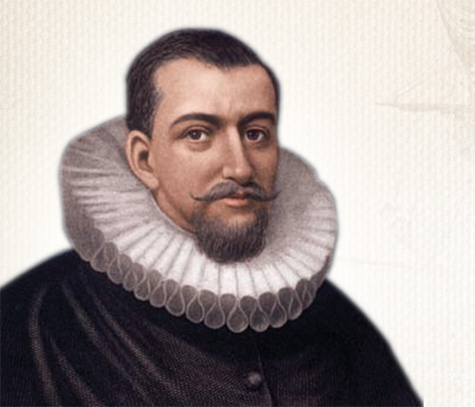

Notes: _______________
_______________________________________________________________
_____________________

Sir Francis Drake (1540-1596)
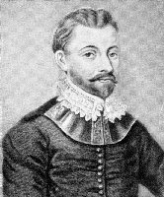
Country Explored For: __________________
Dates of Exploration: __________________
Goals: ______________________________
Discoveries & Achievements: ____________
____________________________________
____________________________________
____________________________________
____________________________________

Notes: _______________
_______________________________________________________________
_____________________

